- leave longitude and latitude

- clean corrupt text in city - by find and replace

- cuisine - multiple items - separate by deliminator

- delete blank cuisine

- take 7% of total restaurant

- translate multiple language in the data to english

- divide restaurant into active and passive restaurant. (dont discard blank average cost of 2)

- remove duplicate values

- Trim

- capitalize

- missing values

- apply currency converter to make one type

- how to do clean - make a copy of your data and clean, when you are confident use it.

Task 2

categorize restaurant by ratings - check if rating in sync with text. Use Pivot table

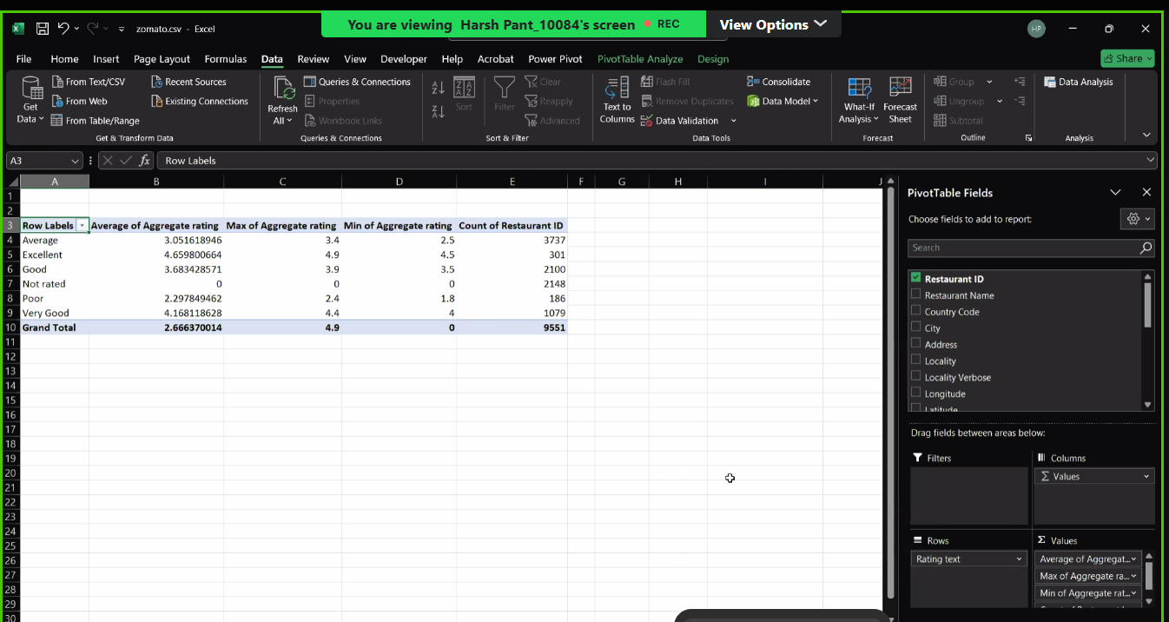

Task 3 – Vlook up (with city name)

Task 4 –

Task – 5 - use aggregate rating , index-match

Task 6 –

Task 7 – heat map

Task -8 Pivot chart

Task -10 – Sparkline

* Doubt – Country code – not available for all the countries
* Rating text is 4 but rating color is 3
* How to bifurcate the cuisine? Do we need to add multiple rows?